Writing a data-driven news story

We are going to write a data-driven story about college tuition costs in Michigan. To start:

We are going to use Google’s Advanced Search function to find a data set to use.

1: Go to Google.com/advanced_search
2: Search for these words:
- Michigan
- College
- Comparison
3. Add file type of xls (excel)
4. Search. You shoud see a result that looks like this:
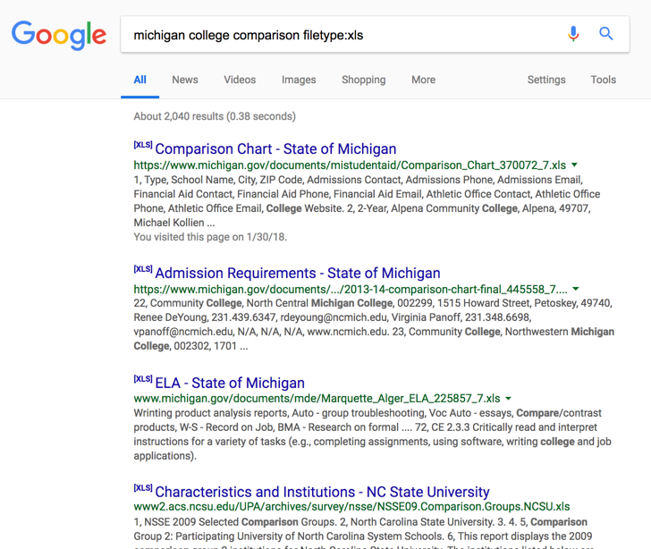

5. For purposes of this exercise, we’ll use that top search result. Download the file to your computer and open it.
6. Take a look at it; scroll through the different tabs at the bottom. What is here? What information does it represent? Can you tell what years this is for? How?
7. You’ll notice this spreadsheet is “locked” so you can’t do anything to it as is. The easiest way to get around this is to copy the information to a new spreadsheet. Let’s do that now. Create a new excel document, and go to each tab of the original.

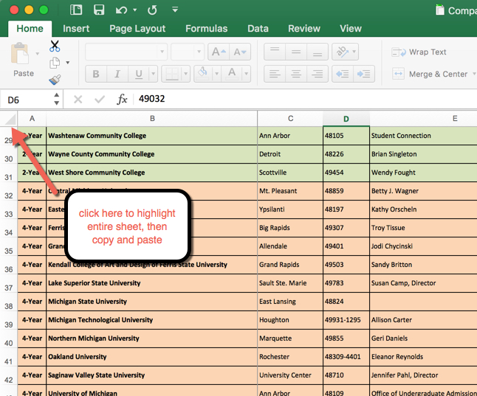

8. Click to highlight sheet as shown here, and copy and paste to your new excel spreadsheet. (you can use google as well)
9. Now, we are going to focus on the costs tab. Go to that tab. Sort the first column as shown:

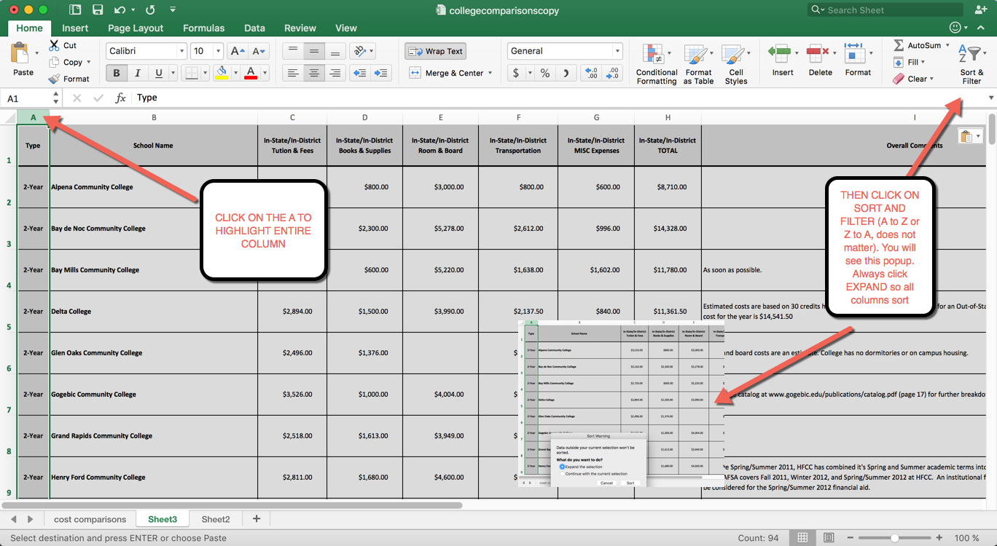

10. After you have sorted, delete the rows that are NOT 4-year colleges.

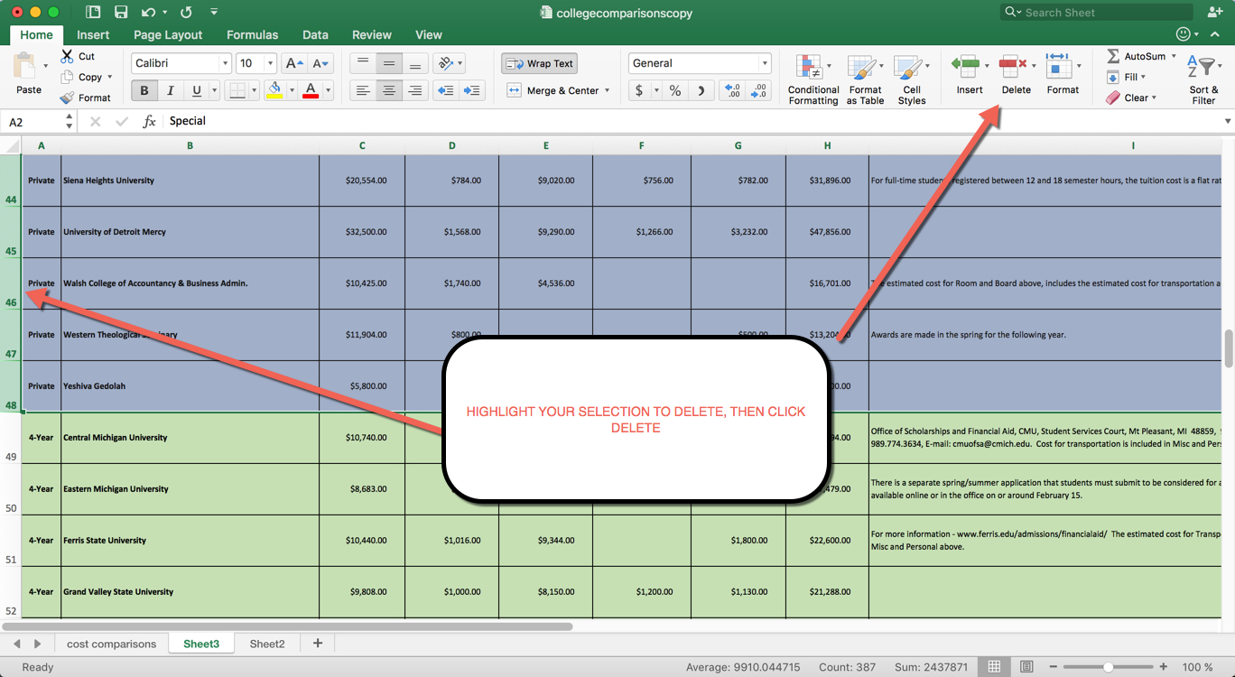

You should be left with a small number of schools, all public 4-year universities.

- How many schools are here?
- Sort by total costs, then by tuition and fees. Is there a difference in the results? Which school is most expensive?
- Are there any “comments” that mitigate that result?
- What else do you notice?

Based on what you see, write a 5-6 paragraph story. Here’s how it should be organized:

THE LEDE:
Answer the 5 W’s and H (or as many as you can) -- who, what, where, when, why and how. Answer the 6 things before you even write the lede.

NEXT GRAF:
Context or support for the lede.

NEXT GRAF:
More context and support, using numbers and data to bolster your story.

Make sure you use at least 3-5 facts and data found in this chart, and anything else you analyzed or found as a result of what you see here. For example, based on these numbers for this 2011-2012 year, you may want to look at what the costs are at U of M Dearborn for this year, and use that to say how much costs have risen in that time. Or, you may want to go back and compare to private schools. There are lots of things you can do.

Before you write that lede ...

Here a story that MLive did this year on college tuition costs, filled with this very kind of data. It may give you an idea of how this is done:

http://www.mlive.com/news/index.ssf/2017/09/what_senior_citizens_dont_real.html

And the lede to that story (which answers WHO, WHAT, WHERE, WHEN):

In-state freshmen tuition and mandatory fees averages $12,262 at Michigan's 15 public universities for 2017-18, while room and board costs are averaging $9,681.

Take a look and see the “5 W’s and H” in the top of this story.

The Chicago Tribune:
Hoping to stem an exodus of local students to colleges in other states (WHY), the University of Illinois (WHO, WHERE) plans to freeze its base tuition for incoming, in-state freshmen for a fourth consecutive year (WHAT), the Tribune has learned.
University President Timothy Killeen will recommend extending the tuition freeze for Illinois residents who enroll this fall (WHEN), he told the Tribune in an interview Thursday. The board of trustees is scheduled to vote on Killeen’s proposal at its meeting Jan. 18. (HOW)
Ready to give it a try?

